K L UNIVERSITY
FRESHMAN ENGINEERING DEPARTMENT

A Project Based Lab Report On

Quiz Assessment & Performance Analytics System

SUBMITTED BY:
ID NUMBER NAME
2500032177 B.SAI SWAROOP

UNDER THE ESTEEMED GUIDANCE OF
MS.A.SMITHA KRANTHI
ASSISTANT PROFESSOR



KL UNIVERSITY
Green fields, Vaddeswaram – 522 502 Guntur Dt., AP, India.

DEPARTMENT OF BASIC ENGINEERING SCIENCES



CERTIFICATE

This is to certify that the project based laboratory report entitled “Quiz Assessment & Performance Analytics System” submitted by B.SAISWAROOP bearing Regd. No. 2500032177 to the Department of COMPUTER SICENCE ENGINEERING , KL University in partial fulfillment of the requirements for the completion of a project based Laboratory in “PYTHON PROGRAMING (25SC2007)” course in I B Tech 2Semester, is a Bonafede record of the work carried out by him/her under my supervision during the academic year 2025 – 2026.

PROJECT SUPERVISOR HEAD OF THE DEPARTMENT MS.A.SMITHA KRANTHI Dr. D. HARITHA

ACKNOWLEDGEMENTS

It is great pleasure for me to express my gratitude to our honorable President.

Sri. Koneru Satyanarayana, for giving the opportunity and platform with facilities in accomplishing the project-based laboratory report.
I express sincere gratitude to our Director Dr. A. Jagdeesh for his administration towards our academic growth.
I express sincere gratitude to our Coordinator and HOD-BES Dr. D. Haritha for her leadership and constant motivation provided in successful completion of our academic semester. I record it as my privilege to deeply thank you for providing us with the efficient faculty and facilities to make our ideas into reality.
I express my sincere thanks to our project supervisor MS.SMITHA KRANTHI for her novel association of ideas, encouragement, appreciation, and intellectual zeal which motivated us to venture this project successfully.
Finally, we are pleased to acknowledge our indebtedness to all those who devoted themselves directly or indirectly to making this project a success.

Name: B.SAISWAROOP

ID No: 2500032177

ABSTRACT

The Quiz Assessment & Performance Analytics System (QAPAS) is a Python-based application designed to automate the process of conducting quizzes, evaluating answers, storing results, and analyzing student performance.
Traditional assessment systems rely heavily on manual processes such as paper-based tests and handwritten evaluations, which are time-consuming and prone to human error. This system eliminates these issues by providing:
- Digital quiz conduction
- Automated evaluation
- Instant result generation
- Centralized data storage
- Performance analytics and visualization
The system uses:
- Python OOP concepts
- CSV file handling
- NumPy for calculations
- Pandas for data analysis
- Matplotlib for visualization
This project is highly useful for educational institutions, teachers, and students to improve efficiency and decision-making using data-driven insights.

INDEX

S.NO | TITLE | PAGE NO
1 | Introduction | 6
2 | Aim of the Project | 7
2.1 | Advantages & Disadvantages | 8
2.2 | Future Implementation | 8
3 | Software & Hardware Details | 9
4 | Data Flow Diagram | 10-11
5 | Algorithm for each module | 12
6 | Implementation | 13-15
7 | Integration and System Testing | 16-18
8 | Conclusion | 19

INTRODUCTION

Educational institutions regularly conduct quizzes and assessments to evaluate student performance. However, traditional methods suffer from several limitations:
- Manual checking
- Time-consuming evaluation
- Data mismanagement
- No performance tracking
The QAPAS system solves these problems by providing a fully automated and analytical system.
It allows:
- Conducting quizzes digitally
- Automatic answer checking
- Storing results permanently
- Analyzing performance trends
- Generating graphical reports
This system bridges the gap between basic teaching tools and advanced LMS platforms.

AIM

- Automate quiz conduction and evaluation
- Reduce manual workload
- Store student performance data
- Provide analytical insights
- Improve academic decision-making

ADVANTAGES
• Saves time and effort
• Eliminates human errors
• Instant result generation
• Centralized data storage
• Easy performance tracking
• Graphical analytics

DISADVANTAGES
• Requires basic system knowledge
• Needs Python environment setup
• Dependent on system availabilit

FUTURE IMPLEMENTATION

The Quiz Assessment & Performance Analytics System (QAPAS) has been successfully developed with core functionalities such as quiz conduction, evaluation, result storage, and performance analytics. However, the system can be further enhanced with advanced features to make it more powerful, scalable, and suitable for real-world deployment.

SYSTEM REQUIREMENTS

SOFTWARE REQUIREMENTS:
The major software requirements of the project are as follows: Language: Turbo-C.
Operating system: Windows 10 or more.
Technical requirements: Monitor, CPU, Keyboard, Mouse, etc...

HARDWARE REQUIREMENTS:
The hardware requirements that map towards the software are as follows: RAM: 8 GB.
Processor: i5/i7.

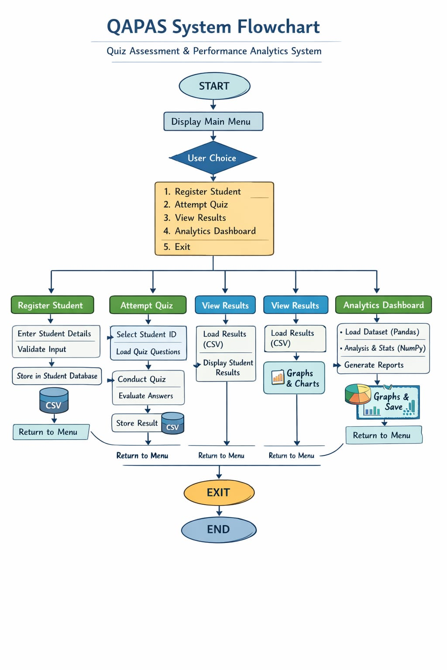

ALGORITHM

Step-1: Start
🔹 Step-2: Display login screen
🔹 Step-3: Read username and password
🔹 Step-4: Validate credentials
- If valid → go to menu
- Else → show error and exit
🔹 Step-5: Display main menu
- Register Student
- Attempt Quiz
- View Analytics
- Generate Graphs
- Exit
🔹 Step-6: Read user choice
🔹 Step-7: If choice = 1
- Input student details
- Check duplicate ID
- Store in dictionary
🔹 Step-8: If choice = 2
- Enter student ID
- Display questions
- Accept answers
- Apply timer
🔹 Step-9: Evaluate answers
- Compare answers
- Calculate score & percentage
🔹 Step-10: Store results in CSV
🔹 Step-11: If choice = 3
- Load CSV
- Calculate average, max, min
🔹 Step-12: If choice = 4
- Generate bar, line, pie charts
🔹 Step-13: If choice = 5
- Exit program
🔹 Step-14: Stop

IMPLEMENTATION

import sqlite3

import os

# =========================

# DATABASE SETUP

# =========================

def init_db():

conn = sqlite3.connect("qapas.db")

cur = conn.cursor()

cur.execute("""

CREATE TABLE IF NOT EXISTS users (

id INTEGER PRIMARY KEY AUTOINCREMENT,

name TEXT

)

""")

cur.execute("""

CREATE TABLE IF NOT EXISTS quizzes (

id INTEGER PRIMARY KEY AUTOINCREMENT,

title TEXT

)

""")

cur.execute("""

CREATE TABLE IF NOT EXISTS questions (

id INTEGER PRIMARY KEY AUTOINCREMENT,

quiz_id INTEGER,

question TEXT,

op1 TEXT,

op2 TEXT,

op3 TEXT,

op4 TEXT,

correct INTEGER

)

""")

cur.execute("""

CREATE TABLE IF NOT EXISTS attempts (

id INTEGER PRIMARY KEY AUTOINCREMENT,

user_id INTEGER,

quiz_id INTEGER,

score INTEGER,

total INTEGER

)

""")

conn.commit()

conn.close()

# =========================

# USER FUNCTIONS

# =========================

def create_user(name):

conn = sqlite3.connect("qapas.db")

cur = conn.cursor()

cur.execute("INSERT INTO users (name) VALUES (?)", (name,))

conn.commit()

uid = cur.lastrowid

conn.close()

return uid

# =========================

# QUIZ MANAGEMENT

# =========================

def create_quiz():

title = input("Enter quiz title: ")

conn = sqlite3.connect("qapas.db")

cur = conn.cursor()

cur.execute("INSERT INTO quizzes (title) VALUES (?)", (title,))

conn.commit()

print("Quiz created!")

conn.close()

def add_question():

quiz_id = int(input("Enter Quiz ID: "))

question = input("Enter question: ")

options = []

for i in range(1, 5):

options.append(input(f"Option {i}: "))

correct = int(input("Correct option (1-4): "))

conn = sqlite3.connect("qapas.db")

cur = conn.cursor()

cur.execute("""

INSERT INTO questions (quiz_id, question, op1, op2, op3, op4, correct)

VALUES (?, ?, ?, ?, ?, ?, ?)

""", (quiz_id, question, options[0], options[1], options[2], options[3], correct))

conn.commit()

conn.close()

print("Question added!")

def list_quizzes():

conn = sqlite3.connect("qapas.db")

cur = conn.cursor()

cur.execute("SELECT * FROM quizzes")

quizzes = cur.fetchall()

print("\nAvailable Quizzes:")

for q in quizzes:

print(f"{q[0]}. {q[1]}")

conn.close()

# =========================

# QUIZ ATTEMPT

# =========================

def attempt_quiz(user_id):

list_quizzes()

quiz_id = int(input("Enter quiz ID to attempt: "))

conn = sqlite3.connect("qapas.db")

cur = conn.cursor()

cur.execute("SELECT * FROM questions WHERE quiz_id=?", (quiz_id,))

questions = cur.fetchall()

score = 0

for q in questions:

print("\n", q[2])

print("1.", q[3])

print("2.", q[4])

print("3.", q[5])

print("4.", q[6])

try:

ans = int(input("Your answer: "))

except:

ans = 0

if ans == q[7]:

score += 1

total = len(questions)

print(f"\nFinal Score: {score}/{total}")

# Save attempt

cur.execute("""

INSERT INTO attempts (user_id, quiz_id, score, total)

VALUES (?, ?, ?, ?)

""", (user_id, quiz_id, score, total))

conn.commit()

conn.close()

# Save to file (Week 7 feature)

with open("scores.txt", "a") as f:

f.write(f"{user_id}:{quiz_id}:{score}/{total}\n")

# =========================

# ANALYTICS

# =========================

def user_report(user_id):

conn = sqlite3.connect("qapas.db")

cur = conn.cursor()

cur.execute("""

SELECT quizzes.title, attempts.score, attempts.total

FROM attempts

JOIN quizzes ON attempts.quiz_id = quizzes.id

WHERE attempts.user_id=?

""", (user_id,))

data = cur.fetchall()

print("\n📊 Your Performance:")

for d in data:

print(f"{d[0]} → {d[1]}/{d[2]}")

conn.close()

def overall_analytics():

conn = sqlite3.connect("qapas.db")

cur = conn.cursor()

cur.execute("SELECT score, total FROM attempts")

rows = cur.fetchall()

if not rows:

print("No data available")

return

total_score = sum(r[0] for r in rows)

total_questions = sum(r[1] for r in rows)

avg = (total_score / total_questions) * 100

print(f"\n📈 Overall Average Score: {round(avg,2)}%")

conn.close()

def show_file_scores():

if not os.path.exists("scores.txt"):

print("No file data yet.")

return

print("\n📁 File Records:")

with open("scores.txt", "r") as f:

for line in f:

print(line.strip())

# =========================

# MENU SYSTEM

# =========================

def menu():

print("\n====== QAPAS SYSTEM ======")

print("1. Create Quiz")

print("2. Add Question")

print("3. Attempt Quiz")

print("4. User Report")

print("5. Overall Analytics")

print("6. Show File Records")

print("7. Exit")

# =========================

# MAIN PROGRAM

# =========================

def main():

init_db()

name = input("Enter your name: ")

user_id = create_user(name)

while True:

menu()

choice = input("Enter choice: ")

if choice == "1":

create_quiz()

elif choice == "2":

add_question()

elif choice == "3":

attempt_quiz(user_id)

elif choice == "4":

user_report(user_id)

elif choice == "5":

overall_analytics()

elif choice == "6":

show_file_scores()

elif choice == "7":

print("Exiting...")

break

else:

print("Invalid choice!")

if __name__ == "__main__":

main()

INTEGRATION AND SYSTEM TESTING
OUTPUTS

Screen Shots:

